Gray Scott Simulation Examples  
Brendan Kelly  
OOSD Semester 1, 2017

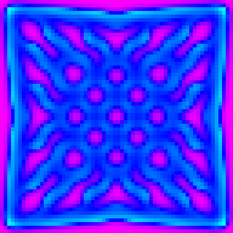  
FeedA: 0.032  
KillB: 0.056  
Laplacian function: Perpendicular  
Shading algorithm: Long Rainbow

Seed algorithm: Centre Four  
Cell grid size: 64x64  
Timesteps: 2094

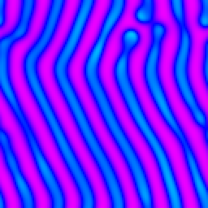

FeedA: 0.025  
KillB: 0.056  
Laplacian function: Convolution  
Shading algorithm: Long Rainbow

Seed algorithm: Centre four  
Cell grid size: 128x128  
Timesteps: 808439

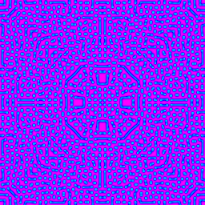

FeedA: 0.031  
KillB: 0.061  
Laplacian function: Perpendicular  
Shading algorithm: Long rainbow

Seed algorithm: Four corners  
Cell grid size: 256x256  
Timesteps: 50000



FeedA: 0.025  
KillB: 0.056  
Laplacian function: Convolution  
Shading algorithm: Long rainbow

Seed algorithm: Centre four  
Cell grid size: 64x64  
Timesteps: 23162

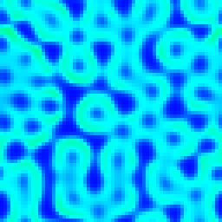

FeedA: 0.021  
KillB: 0.049  
Laplacian function: Perpendicular  
Shading algorithm: Short Rainbow

Seed algorithm: Random sixteen  
Cell grid size: 64x64  
Timesteps: 20000

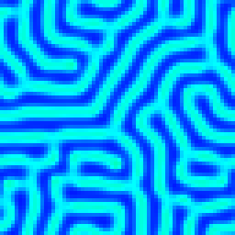

FeedA: 0.025  
KillB: 0.054  
Laplacian function: Perpendicular  
Shading algorithm: Short rainbow

Seed algorithm: Random sixteen  
Cell grid size: 64x64  
Timesteps: 20000

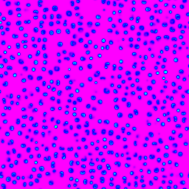

FeedA: 0.011  
KillB: 0.051  
Laplacian function: Perpendicular  
Shading algorithm: Long rainbow

Seed algorithm: Random sixteen  
Cell grid size: 256x256  
Timesteps: 10000

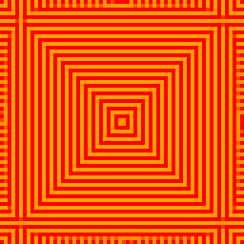

FeedA: 0.069  
KillB: 0.010  
Laplacian function: Delta Means  
Shading algorithm: Long rainbow

Seed algorithm: Centre sixty-four  
Cell grid size: 64x64  
Timesteps: 20000

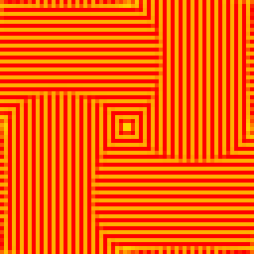

FeedA: 0.069  
KillB: 0.018  
Laplacian function: Delta Means  
Shading algorithm: Long rainbow

Seed algorithm: Centre sixty-four  
Cell grid size: 64x64  
Timesteps: 20000

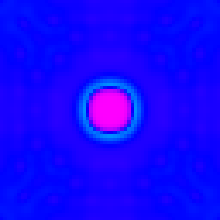

FeedA: 0.026  
KillB: 0.052  
Laplacian function: Perpendicular  
Shading algorithm: Long rainbow

Seed algorithm: Centre four  
Cell grid size: 64x64  
Timesteps: 2000